Course Intro

Applications of ML:

Self Driving Cars

Cybersecurity

Stock market trading

Medical diagnosis

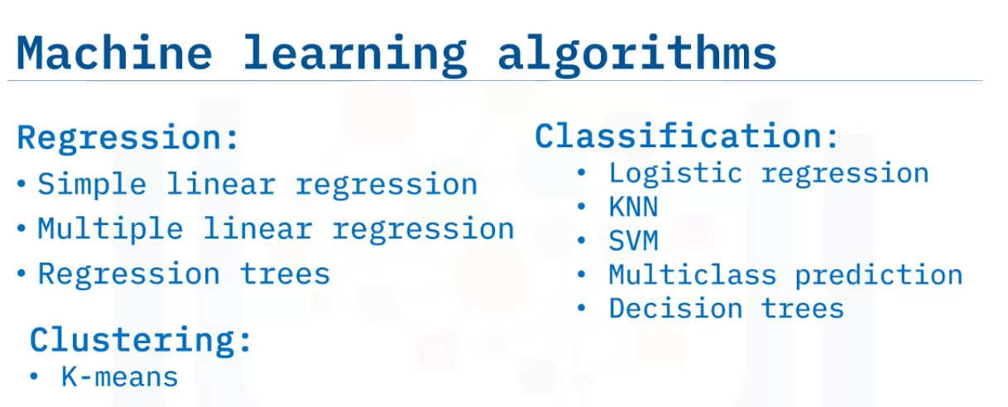

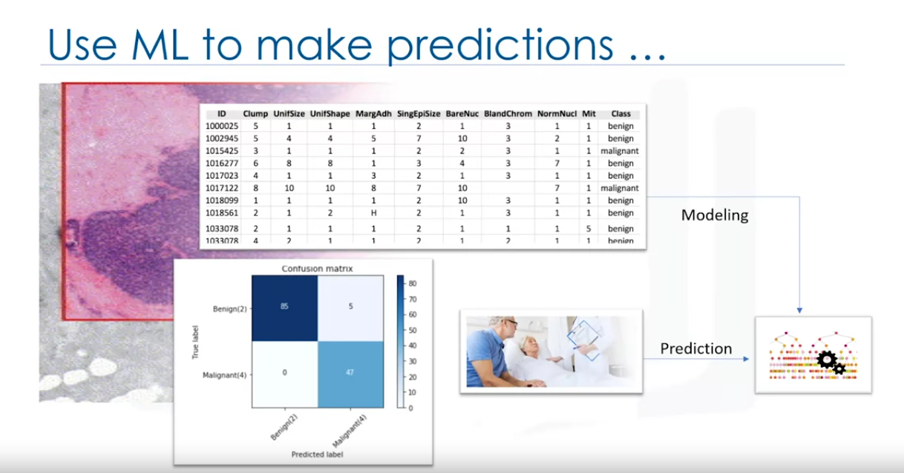

ML is used in many different industries like:

Health Care in which Data Scientists use ML to predict whether a human cell that is believed to be at risk of developing Cancer is either benign or malignant.

ML can play a key role in determining a person’s health and welfare.

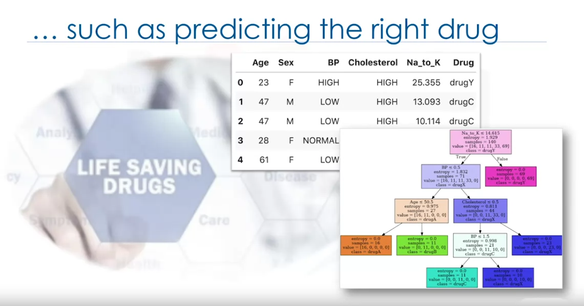

You’ll also learn about the value of decision trees and how building a good decision tree from historical data helps doctors to prescribe the proper medicine for each of their patients. You’ll learn how bankers use ML to make decision whether to approve loan applications

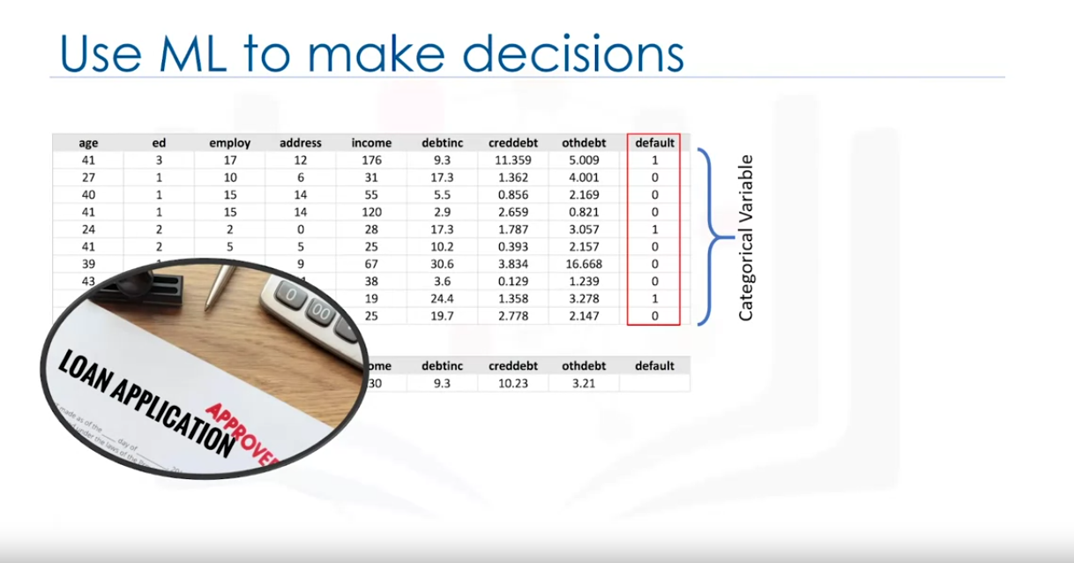

you will learn how to use ML to perform bank customer segmentation where it us not usually easy to run for huge volumes of varied data.

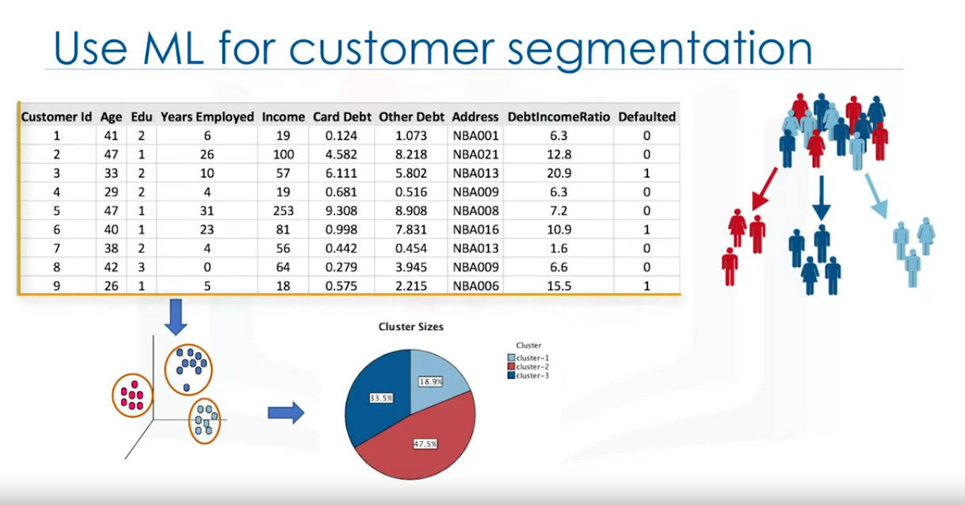

. In this course you’ll see how ML helps websites such as Youtube , Amazon, and Netflix develop recommendations on movies and books.

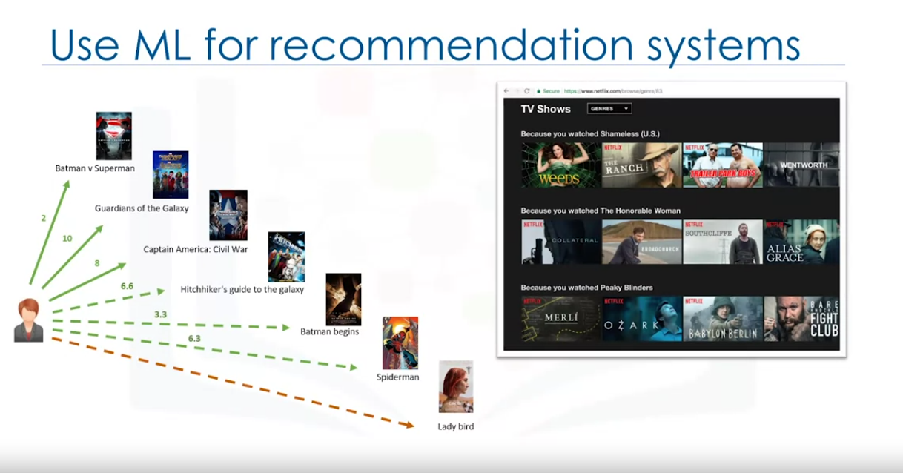

Given data related to automobiles,using python library like scikit learn we can estimate co2 emission of cars which are not yet produced. we can also see customer churn in telecom indust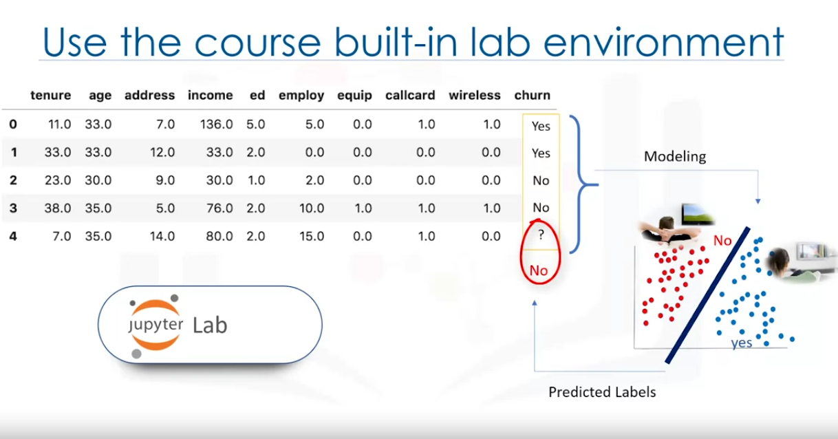

We will learn the following in this course.

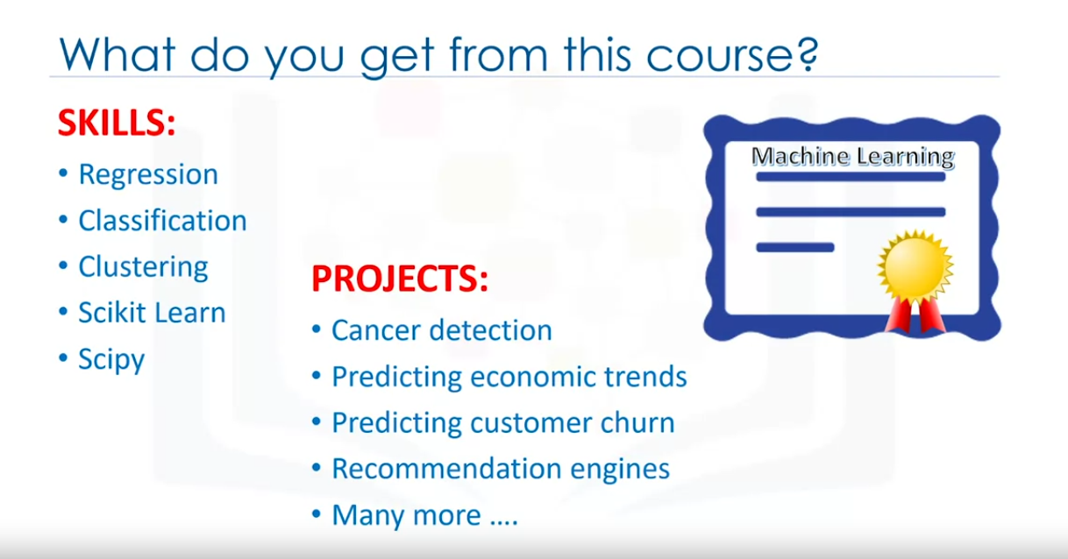

Introduction to ML

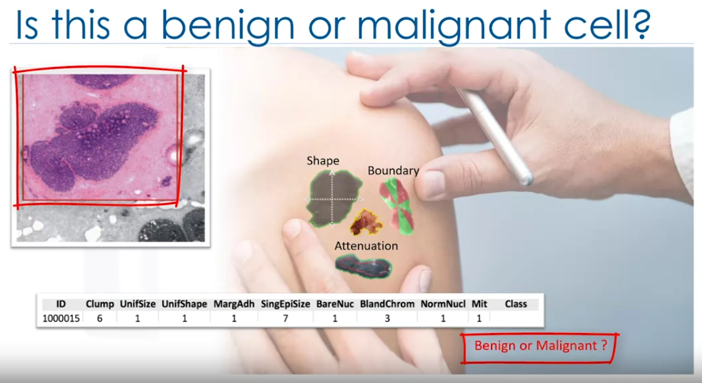

The above image shows human cell sample taken from a patient.

It has characterstics as clum 6, Its uniformity of cell size is 1, marginal adhesion is 1 and so on.

One of the interesting questions that we can ask is Is this benign or malignant cell.

A malignant tumor is something that invade its surrounding. Where as the benign one does not spread. Diagnosing this early might be key to patient’s survival.

One could easily presume that only a doctorwith years of experience could diagnose that tumor and say if the patient is developing cancer or not.

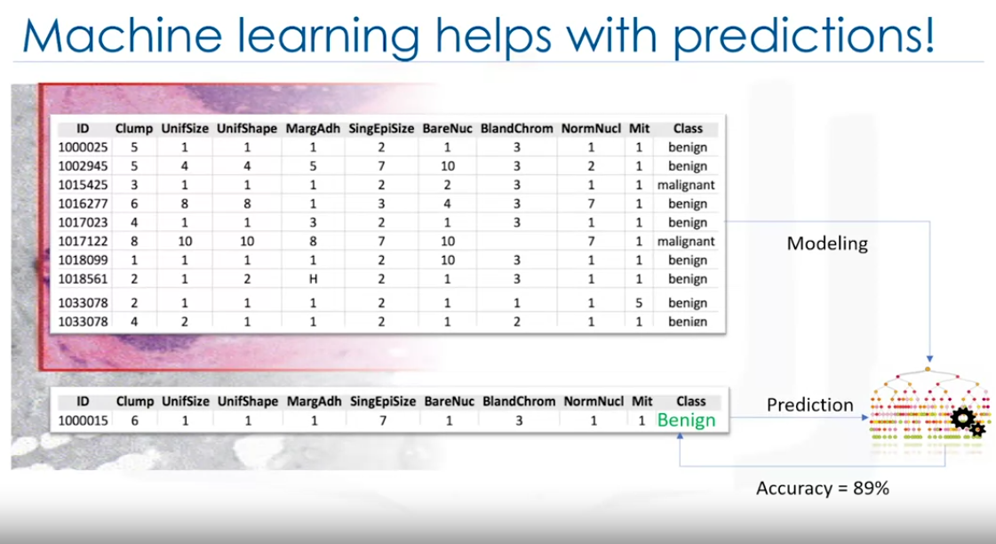

But if we have dataset of characterstics of thousands of patients we can perfrom analysis then we can predict it whit a certain confidence level.

To do this we need to clean the data, select a proper algorithm for building a prediction model, train the model using iterative approach to understand the patterns of benign or malignant cells within the data.

Then we can test the data for accuracy. We can also optimize the model.

Then we can predict the data with higher accuracy.

In this way, the doctor’s job is made easy and faster to determine if the patient has cancer.

Formal definition of ML:

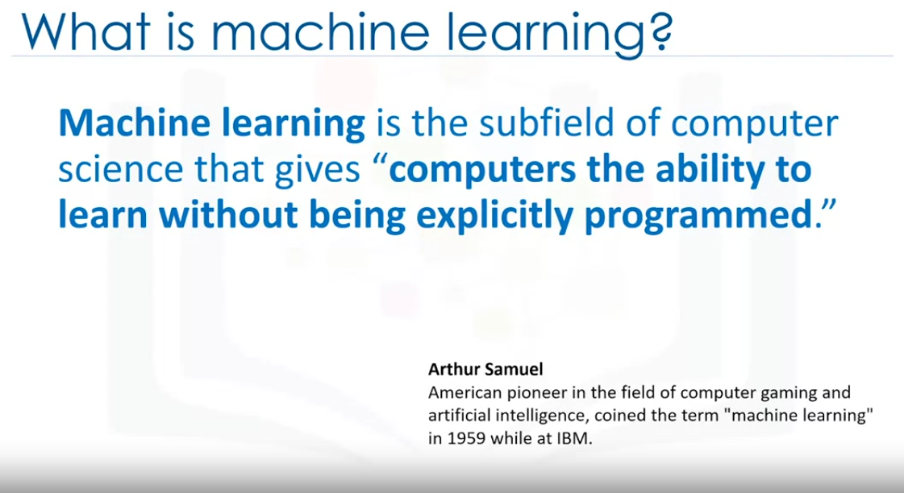

Lets see what it means when we say not explicitly programmed?

Lets say we have a pictures of dogs and animals like cats and dogs.

you want the computer to predicts if the image has a cat or a dog.

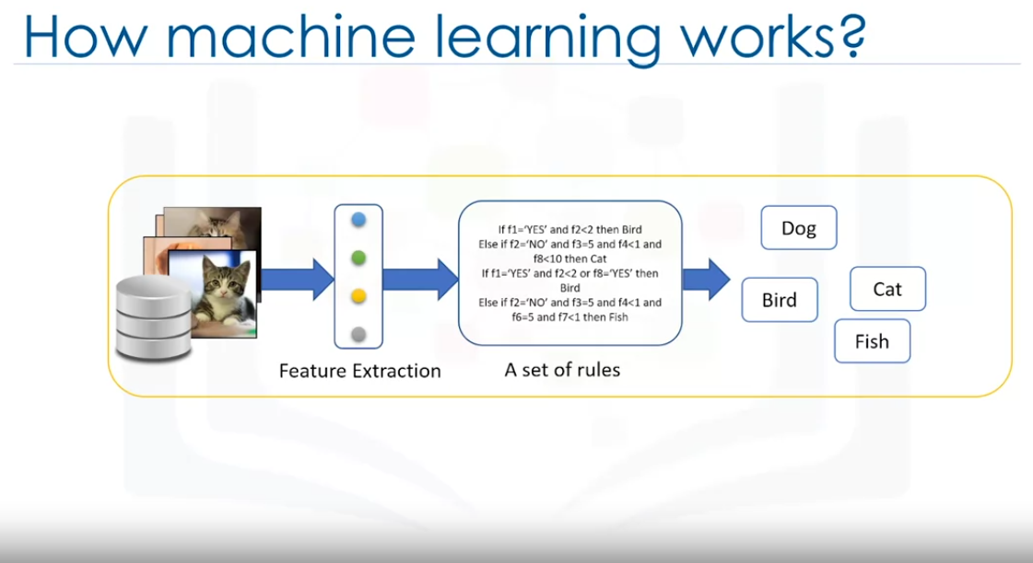

The first thing we ned to do is interpret that the images as a set of feature sets.

For example: does the image shows the animal’s eyes? If so. what is their size? Does it have ears? what about a tail? How many legs? What is its color? Doest it have wings?

Prior to the ML each image would be transformed to a vector of features.

Then traditionally we had to write a set of rules that check different features to make a prediction.

But it was a failure as there can be tons of rules that needs to be written which only works for the current dataset. It is not generalised enough to detect out of sample cases.

For example ,In the above image, we can see that code can prdict if its a dog, Bird, Cat, Fish.But if we provide a picture of human it cannot predict. This is where ML comes into the schene.

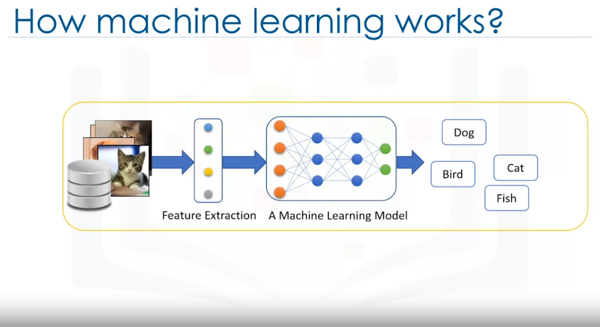

ML allows us to build a model that looks at all the feature sets, and their corresponding type of animals, and it learns the pattern of each animal.

It is a model build by ML algorithms. It detects without explicitly being programmed to do so.

In essence, ML follows the same process that a toddler uses to learn.

So, ML algorithms are inspired by human learning process iteratively learn from data and allow computers to find hidden insights.

These models help us in a variety of tasks such as object recognition, summarization, recommendation and so on.

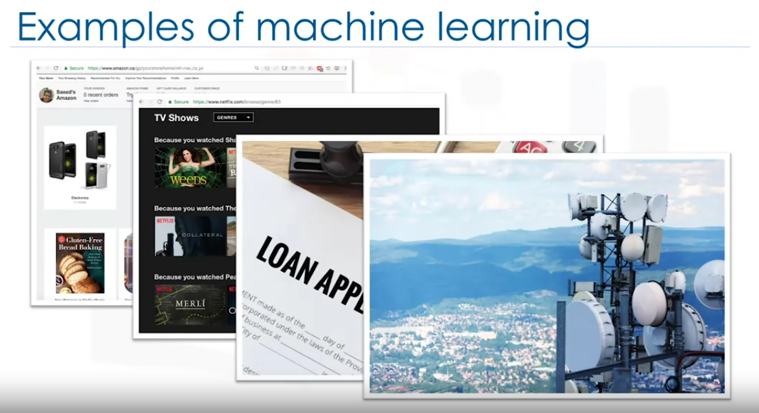

Netflix and Amazon Movies and book recommendation.

Bank loan approval based on defaulting

Weather forcasts.

Customer sengmentation in Telecom.

Many more things like chatbots, face recognition for phones. Each of these use different ML techniques and algorithms.

So lets quickly examine a few of the more popular techniques

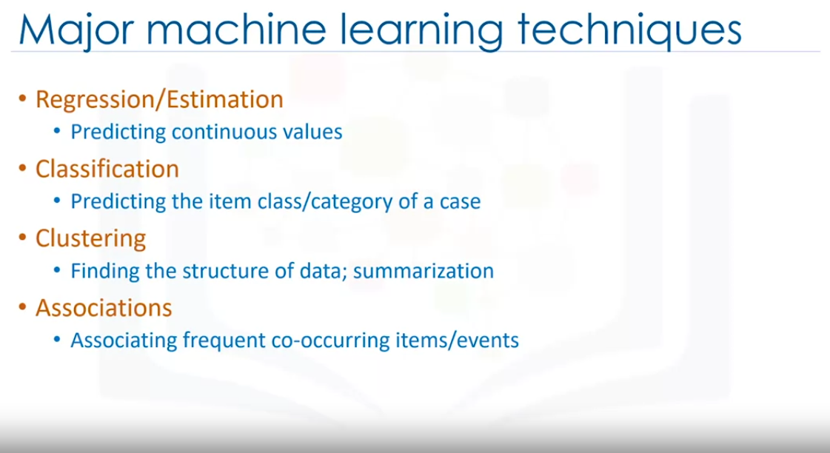  
Regression - Estimating price of house or estimating co2 emissions of a car.

classification - cell is begning or malignant or a customer is going to churn

clustoring = used to find similar patients or used of customer segmenting in banks.

Association -Items purchased together.

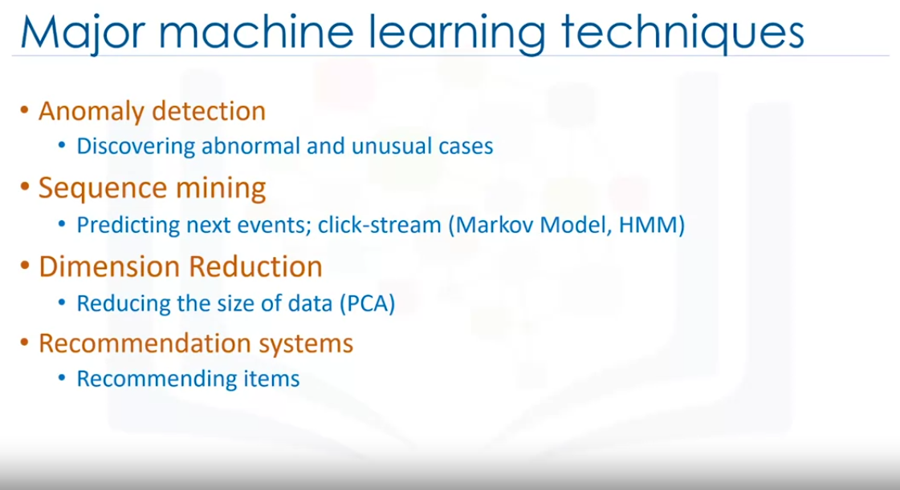

Anomaly detection - credit card fraud

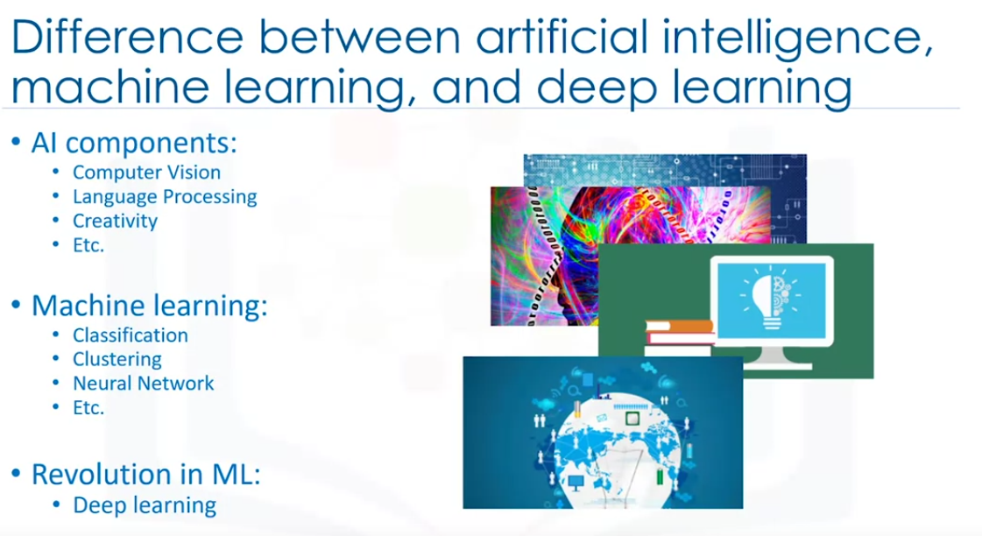

ML vs AI vs Deep Learning:

AI makes computer intelligent in order to mimic the cognitive functions of humans . So, AI is a general field with a broad scope including Computer Vision, Language processing , Creativity, and Summarization.

ML is branch of AI that covers the statistica part of AI. It teaches the computer to solve problems by looking at hundreds or thousands of examples, learning from them and using that experience to solve the same problem in thenew situations.

Deep Learning is a specialised field of Ml where it can learn and make intelligent decisions on its own

It involves deeper level of automation in comparisions to ML algorithms.

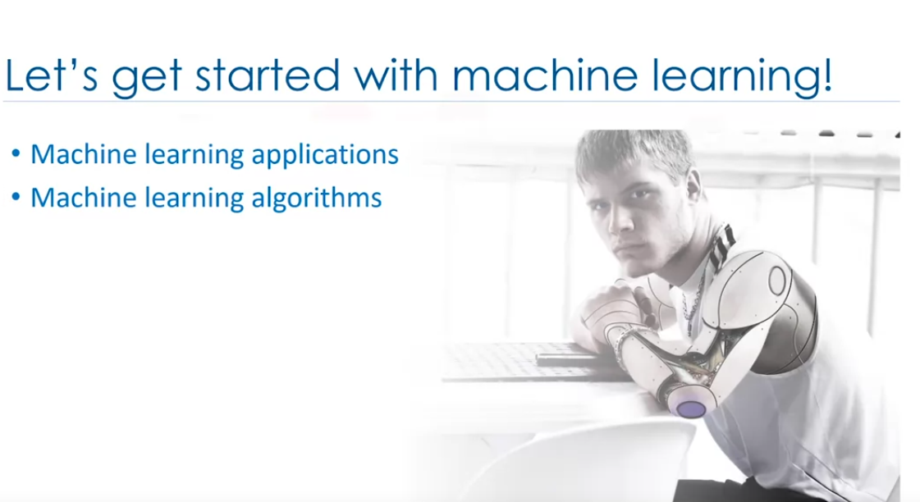

Checkout chargpt_AI_ML_DL docx file for more comparisions

Python for ML

Python is a popular and powerful general purpose programming language that recently emerged as the preferred language among data scientists. You can write your machine learning algorithms using Python, and it works very well.

However, there are a lot of modules and libraries already implemented in Python, that can make your life much easier.

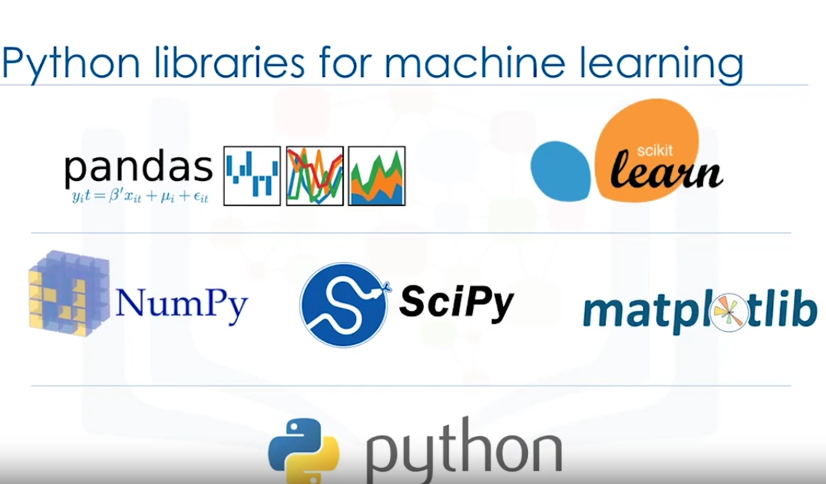

1. Numpy - It is a math library that runs on nd array. It enables effecient and effective computations. Better than regular python. for example to work with arrays, dictionaries, functions, datatypes and working with images, you need numpy.
2. Scipy is a collection of numerical algorithms and domain specific toolboxes, including signal processing, optimization, statistics and muchmore, Scipy is a good library for scientific and high performance computations.

SciPy provides algorithms for optimization, integration, interpolation, eigenvalue problems, algebraic equations, differential equations, statistics and many other classes of problems.

https://scipy.org/

1. Matplotlib - it is a very popular plotting package that provides 2D plottin as well as 3D plotting .

Basic knowledge of these the three packages which are built on top of python is a good asset for data scientists who want to work on real world problems.

1. Pandas is a high-level python library that provides high performance, easy to use data structures (series and dataframes). It has many way to import data from different sourrces, manipulate them and analyse the data. It also has basic ploting capabilities. We can alos use time series data.
2. Sciekitlearn - A collection of ML algorithms that we will focus on.

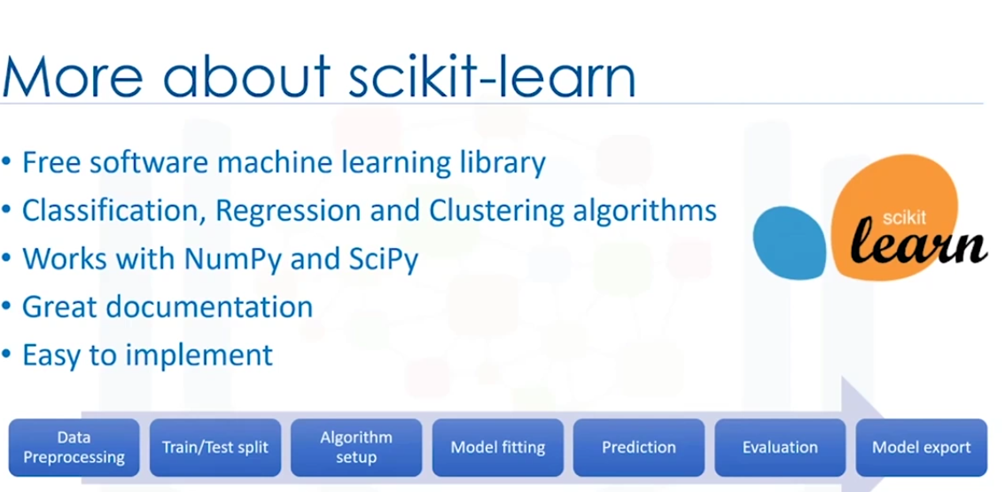

Most of the operations that is needed in the ML pipeline is already implemented in Scikit learn as shown in the image.

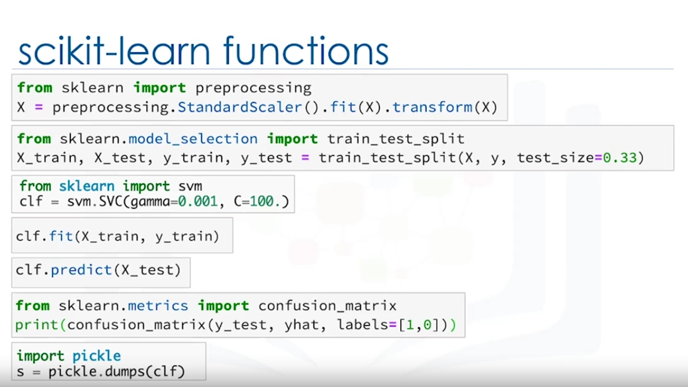

Example of scikitlearn:

ML algorithms benifit from standardization of dataset. which can be done easily with just 2 lines of code above. This helps to transform the data into a suitable format that the ML algorithm needs.

we can split the data into train and test by using 2 lines

we create and fit a model using just 3 lines of code by importing specific model that already exists and creating an object for it with different parameters. the we have a simple method called fit to fit the model with the train data.

we can use the predict method to it with the test data using predict method on the model object.

calculating the accuracy of the model is also simple and we have different methods to do that for example r2_score, confusion matrix etc.

If we use numpy and scipy instead of pandas and scikitlearn, it is way harder to do the same.

In plain python it is even more difficult.

Supervised vs Unsuppervised Learning

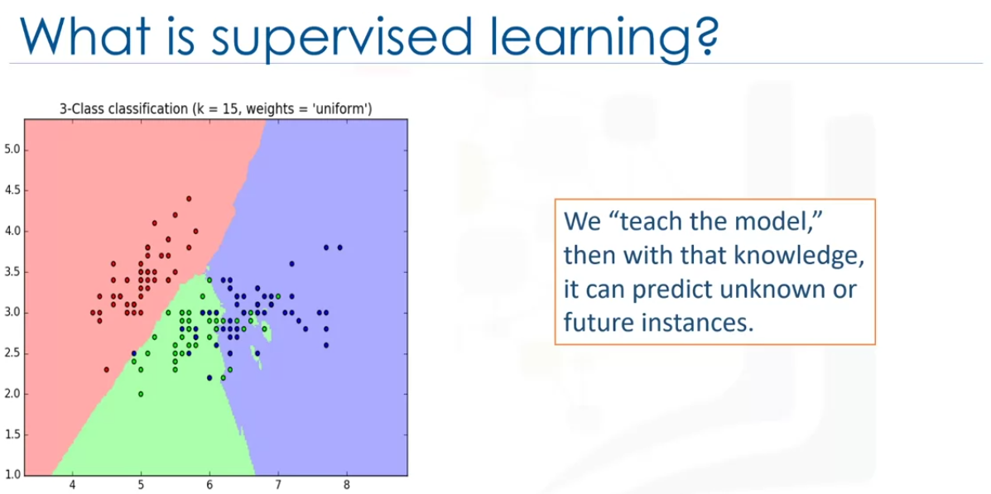

Supervising and directing a task done by a machine learning model that might be able to generate a classification like shown above.

We teach the model then with that knowledge it can predict unknown or future instances.

How do we teach the model?

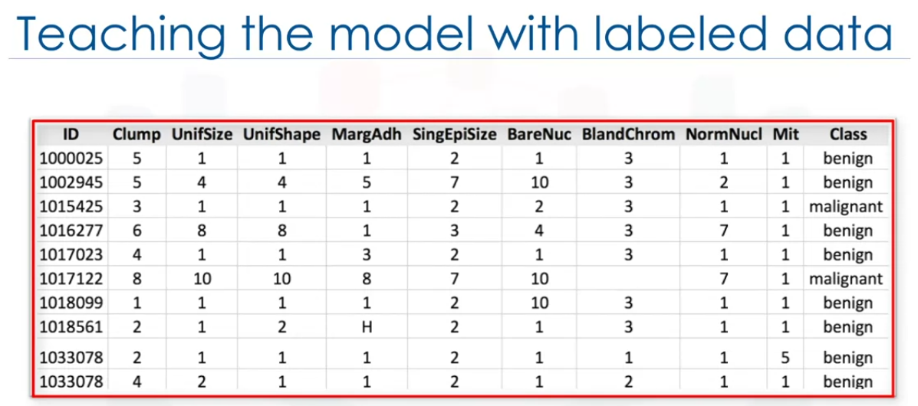

We can provide labeled data like above where it tells if it is benign or malignant cancer.

There are 2 types of supervised learning :

1. classification - classification can put the data into different groups. Can predict categories
2. Regression - Can tell if the two features are correlated or not. Can predict continuos data.

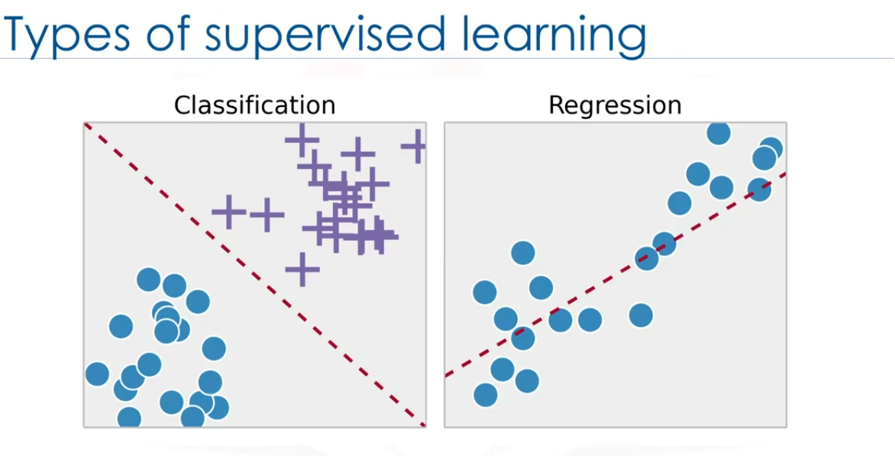

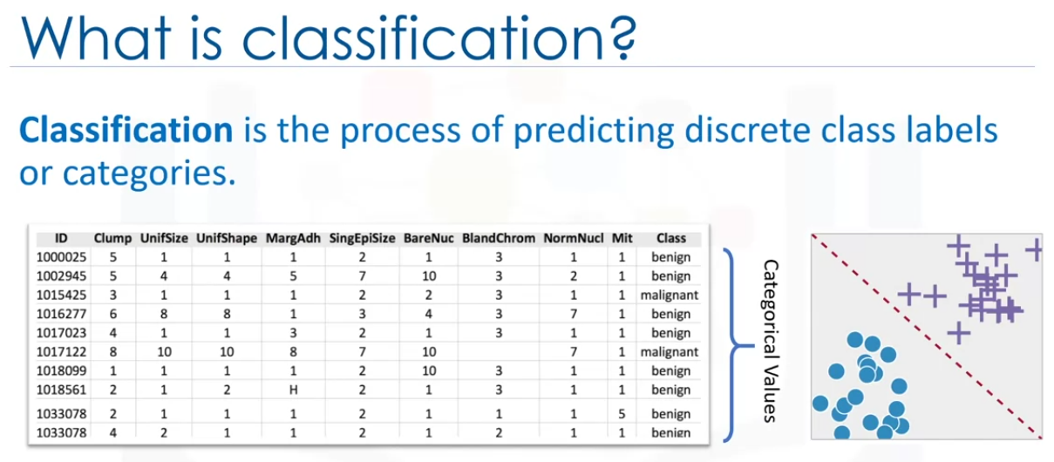

The above data predicts that if the cancer is benign or malignant cancer which are categories.

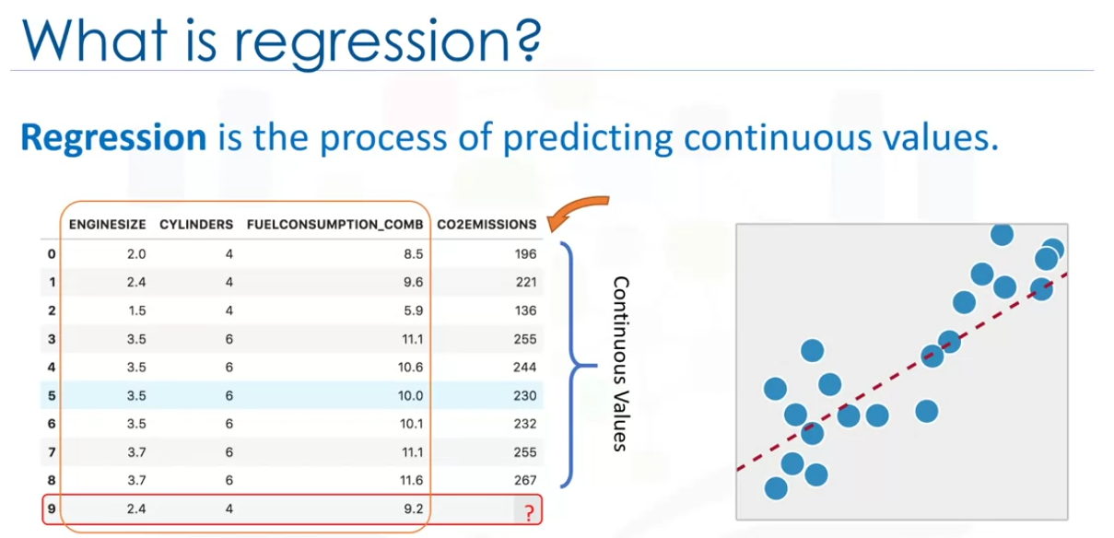

The above data can be used to predict co2 emission for a car that is being created newly which is a continuos value.

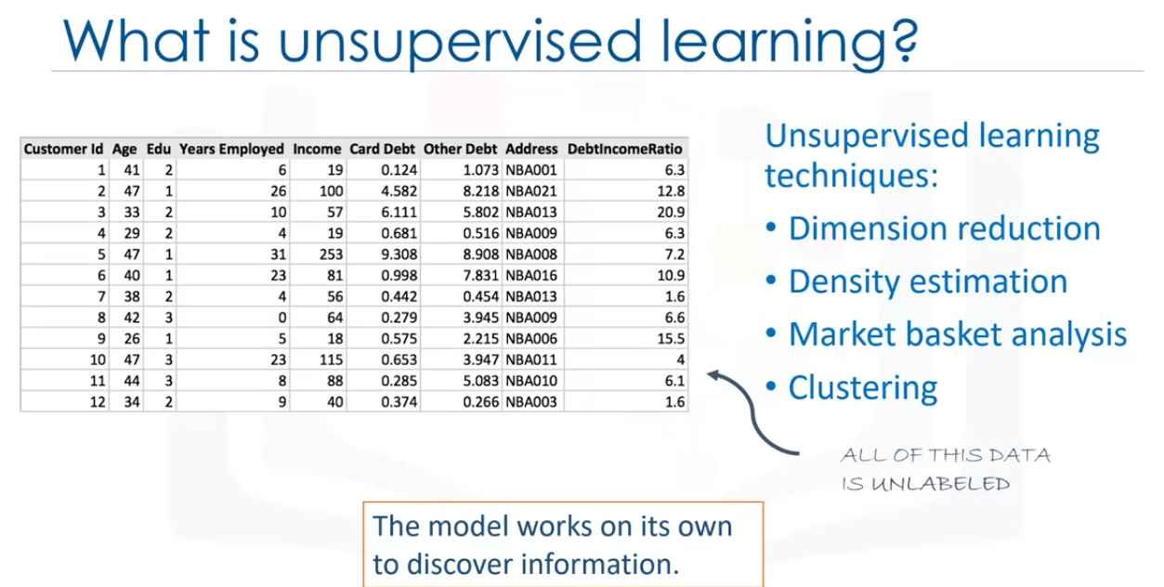

The unsupervised learning tains on the dataset without any labels. has more difficult algorithms as the outcomes are unknown.

Dimension reduction reduces redundant features and makes classification easier.

Market basket analysis tells which elements can be sold together. For example, laptop, keyboard and mouse can be sold together.  
Density estimation is a very simple algoritm used to find some structure within the data.

Clustering groups our data into different clusters and can assign new data to one of those clusters. Most popular ML algorithm

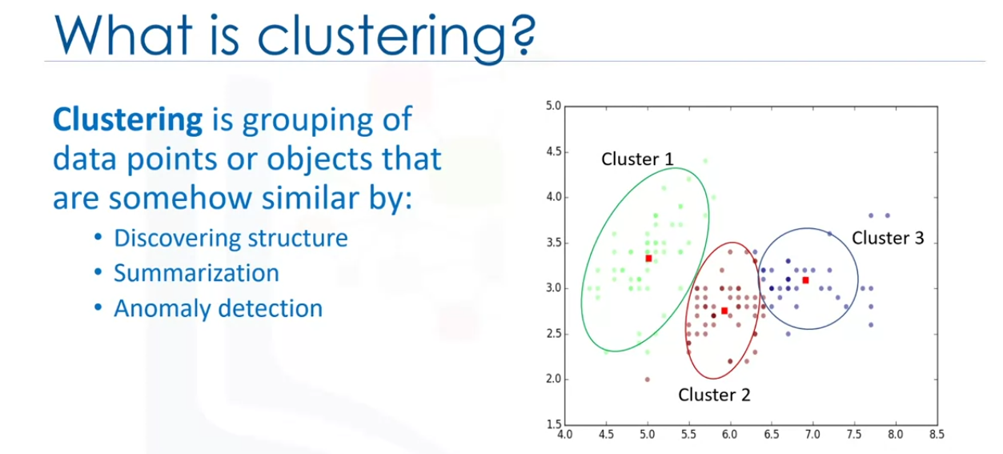

can be used in bank customer segmentation, finding which kind of music that you like and so on.

